

|| Shree Ganesha Namaha ||

Wedding Invitation

With blessings of Late Smt.Kala Devi Srivastava & Late Shri R.S.Karan Srivastava

We solicit your gracious presence on the auspicious occasion of the marriage of my niece

Chi. Sow. Simran

(D/O. Late Smt. Sujata Srivastava & Shri. Sunil Kumar Srivastava)

With

Chi. Aakash

(S/O Smt. Anitha Rani & Shri. Suresh Parshad Srivastav)

On Friday, 26th April 2024

At: 11.30 pm

## Venue: Vanga Ananth Reddy Gardens (VAR)

Opp. Karmanghat Hanuman Temple, Beside Kirana Grand Hotel, Karmanghat, Hyderabad.

Dinner: 9 P.M onwards

From   
Smt. Suman Srivastava & Shri Anil Kumar Srivastava

With Best Compliments

Karan Brother’s & Family.



**Invitation from KARAN Family**

**Simran**



**Aakash**

To ___________________________________________

___________________________________________

___________________________________________

From

Smt. Suman Srivastava

Shri. Anil Kumar Srivastava

(Contact Details)

Address ,  
A1  
N1

**Wednesday | 24 | April**

__________________________________

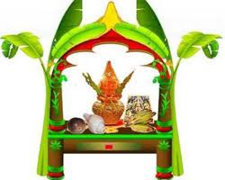Katha : 4 P.M

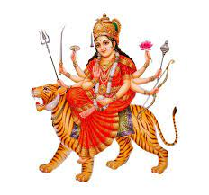Rathjaga : 6 P.M 

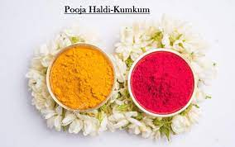Tilak : 7 P.M

Dinner : 9 P.M onwards

At Our Residence,

Charminar

**Thursday | 25 | April**

__________________________________

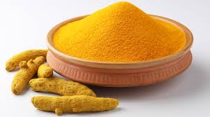 Haldi : 11 A.M 

Lunch : 1:30 P.M onwards

At Our Residence,

Charminar